http://ejournal.stipjakarta.ac.id
 | METEOR STIP MARUNDA
pISSN : 1979 - 4746  eISSN : 2685 - 4775 | Maritime Institute of Jakarta

Title of the Article in Title Case: Concise, Informative, and Free of Abbreviations
First Author¹, Second Author², Third Author³
¹Study Program/Department, Faculty, Institution, City, Country
²Study Program/Department, Faculty, Institution, City, Country
³Study Program/Department, Faculty, Institution, City, Country

*Email Correspondence: corresponding.author@institution.ac.id
Submitted: dd/mm/yyyy | Revised: dd/mm/yyyy | Accepted: dd/mm/yyyy | Published: dd/mm/yyyy
Abstract
The abstract is a single paragraph of no more than 250 words, written in English in Times New Roman 11 pt italic and justified. It must stand on its own. State the background and the problem in one or two sentences, then the purpose of the study, the method (design, data, sample, and analysis), the main findings with the key figures that support them, and the conclusion or practical implication. Use the most important keywords in the first two sentences. Do not include citations, tables, figures, or equations, and keep abbreviations to a minimum, defining any that are used. Report what was done and found in the past tense, and avoid opening phrases such as "This paper discusses". Provide three to five keywords below, separated by semicolons. Replace this paragraph with your abstract.
Copyright ©YYYY, METEOR STIP MARUNDA, pISSN: 1979-4746, eISSN: 2685-4775
Keywords:
Keyword One; Keyword Two; Keyword Three; Keyword Four; Keyword Five

1. INTRODUCTION
This template sets out the layout of articles published in METEOR STIP MARUNDA. Type or paste your text over the placeholder text so that the page settings, columns, fonts, and spacing are preserved; when pasting from another file, use Paste Special and keep text only. The page is US Letter (21.59 × 27.94 cm) with a top margin of 2.54 cm, a bottom margin of 2.22 cm, and left and right margins of 2.0 cm. Body text is Times New Roman 11 pt, single-spaced and justified, in two columns 0.95 cm apart. Each paragraph begins with a 1.27 cm first-line indent, with no extra space between paragraphs.
The Introduction presents the background of the problem, the research objective and its significance, a review of relevant and recent literature, and the gap or novelty that the study addresses, and it ends with the aim of the study and, where applicable, its hypothesis. Do not use subsections in the Introduction. Sources are cited with numbers in square brackets in the order in which they first appear, for example [1], [2] or [3]-[5], and a source keeps its number each time it is cited again. Write in American English unless you state on the first page that British English is used.
Level 1 headings are numbered, bold, and in capital letters (1. INTRODUCTION) and are preceded by 12 pt of space. Level 2 headings are numbered and bold in title case (3.1. Results). Level 3 headings are unnumbered and italic in title case (Data Collection). Keep abbreviations to a minimum and define each one at first use.

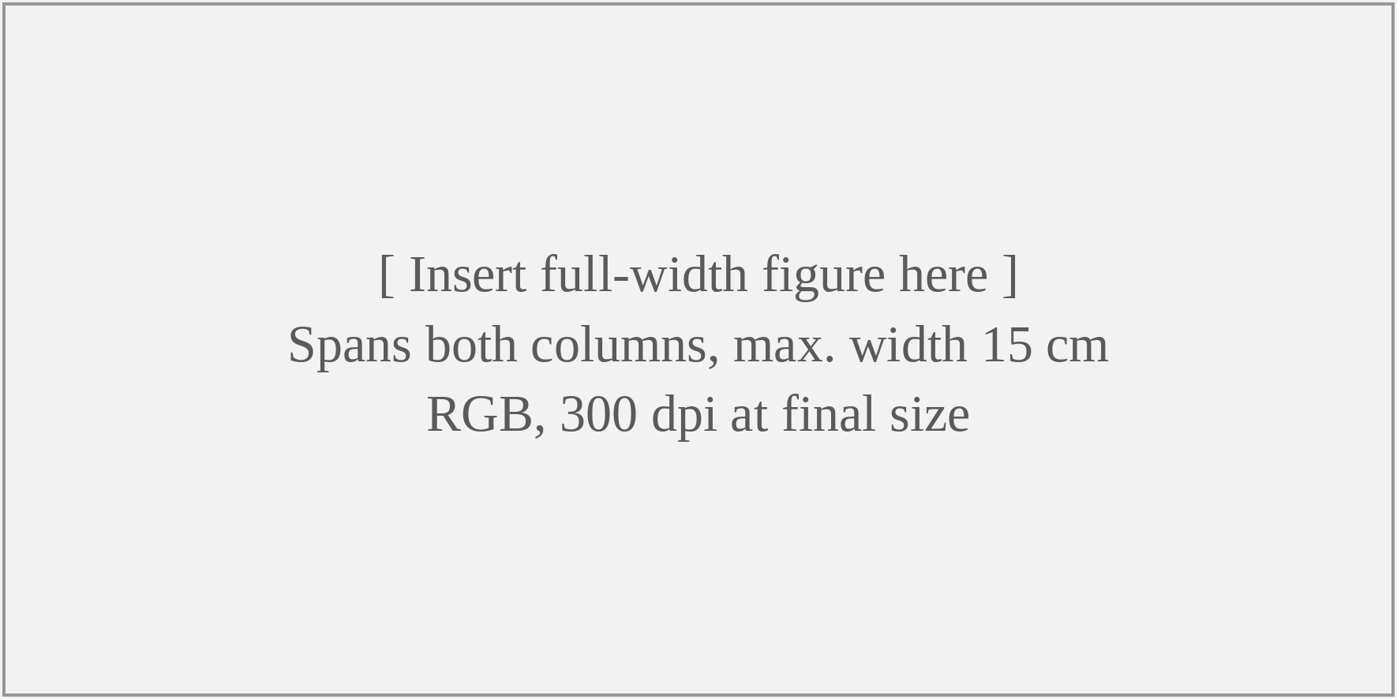
Figure 1. Caption of a Full-Width Figure in Title Case, Centered Below the Figure, with the Source in Brackets if It Is Not Original [1]

Figures and tables are numbered consecutively in Arabic numerals and are referred to in the text before they appear (Figure 1, Table 1). A figure too wide for one column is placed in a one-column section, as Figure 1 is: insert a continuous section break before and after it and set that section to one column (Layout > Breaks > Continuous, then Layout > Columns > One). Smaller figures stay inside the column, as Figure 2 does.
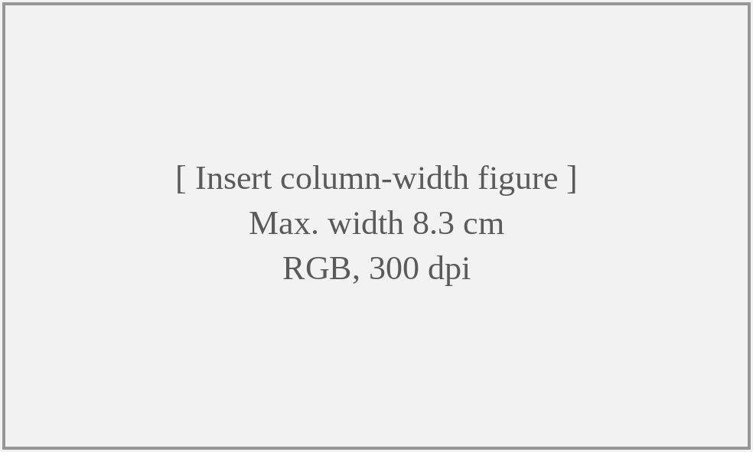
Figure 2. Caption of a Column-Width Figure
Figure captions go below the figure and table captions above the table. Both are centered in 11 pt, with the label in bold (Figure 1., Table 1.) followed by the caption in title case. Use original figures with legible labels, units, and scale bars, at 300 dpi in RGB. Do not include photographs of identifiable people, trademarked logos, or figures that repeat data already given in a table.
2. RESEARCH METHOD
Research Design
The Method section gives enough detail for another researcher to evaluate and replicate the study. Describe the research design, the setting and period of the study, the population and sampling procedure, the instruments or equipment used, the data collection procedure, and the analysis, including validity and reliability testing and the statistical tests applied. Established methods are cited rather than described in full, and any changes made to them are explained.
Data Collection
Use level 3 headings to divide the Method into logical parts, such as Research Setting, Data Collection, and Data Analysis. For maritime field studies, state the vessel or port, the equipment specifications, the operating conditions, and, where relevant, the regulatory framework that applies (for example SOLAS, MARPOL, or the ISM Code).
Data Analysis
Equations are typed with the Word equation editor, centered in the column, and numbered consecutively in parentheses at the right margin. Refer to them in the text as Equation (1).
$\overline{x}=\frac{1}{n}\sum_{i=1}^{n}{x_{i}}$ (1)
where x̄ is the sample mean, x_{i} is the i-th observation, and n is the number of observations. Symbols are italicized in the text exactly as they appear in the equation and are defined immediately after it.
3. RESULTS AND DISCUSSIONS
3.1. Results
Subheading in Title Case
Present the results in a logical sequence in the text, tables, and figures, without repeating in the text all the data given in a table. Emphasize the main findings and the values that support them, and report each statistical result with the test used, the test statistic, and the significance level.
Tables use horizontal lines only: one above and one below the header row and one below the last row, with no vertical lines. Table text is 9 pt with a bold header row, and notes go directly below the table in 9 pt. Tables are inserted as editable Word tables, not as images. A wide table is placed in a one-column section in the same way as a full-width figure (Table 1).

Table 1. Caption of the Table in Title Case, Placed Above the Table
Variable | Unit | Mean | SD | Interpretation
Variable 1 | unit | 0.00 | 0.00 | Description
Variable 2 | unit | 0.00 | 0.00 | Description
Variable 3 | unit | 0.00 | 0.00 | Description
Total/Average | - | 0.00 | 0.00 | Description
Note: Explanatory notes, abbreviations, and the data source are written here in 9 pt [2].

Subheading in Title Case
A narrow table may stay within the column. After a closing section break, the text continues in two columns, as here.
3.2. Discussion
Subheading in Title Case
The Discussion interprets the results rather than repeating them. Explain what the findings mean, compare them with earlier studies [3], [4], and consider alternative explanations. State the practical implications for maritime operations, education, or policy, followed by the limitations of the study and the directions for further research. Claims should stay within what the data support, and a long discussion may be divided with level 3 headings.
4. CONCLUSION
The Conclusion answers the research objective stated in the Introduction. It is a concise synthesis of the main findings and their significance, not a repeat of the abstract or a list of results, and it introduces no new data or arguments. It is usually one paragraph and may close with a recommendation that follows from the findings.
REFERENCES
IEEE style, numbered in order of citation, with DOI where available. Examples:
[1] A. Author, B. Author, and C. Author, "Title of the article in sentence case," Title of the Journal, vol. x, no. x, pp. xx-xx, Year, doi: 10.xxxx/xxxxx.
[2] A. Author, Title of the Book, xth ed. City, Country: Publisher, Year.
[3] A. Author, "Title of the paper," in Proc. Name of the Conference, City, Country, Year, pp. xx-xx, doi: 10.xxxx/xxxxx.
[4] A. Author, "Title of the thesis," M.S. thesis/Ph.D. dissertation, Department, University, City, Country, Year.
[5] International Maritime Organization, Title of the Convention or Code, Year ed. London, U.K.: IMO, Year.
[6] Ministry of Transportation of the Republic of Indonesia, "Regulation of the Minister of Transportation No. PM xx of Year on title of the regulation," Jakarta, Year. [Online]. Available: https://jdih.dephub.go.id
[7] Organization, "Title of the web page," Mon. DD, YYYY. [Online]. Available: https://www.example.com

